**PROPOSAL**

**1.Project Title: Indoor Navigation System for Visually Impaired**

2.Broad Subject: Engineering

3.Sub Area: Computer Networks, Embedded Systems, Wireless Networks

4.Duration in months: 36Months

5.Total Cost:xxxxxxxxxxxxxxx

6.FE Component: Nil

7.Project Category: xxxxxxxxxxxxx

8.Department: Electronics & Communication Engineering

9.Institute name: SSN College of Engineering

Address: Rajiv Gandhi Salai (OMR),

Kalavakkam – 603 110

Tamil Nadu, India.

10.Project Guide1: **Dr. R. Rajavel.**

Designation: Associate Professor.

Sex: Male.

E-mail: rajavelr@ssn.edu.in

Mobile: 9710787108

Project Guide2: **Dr. S. Joseph Gladwin.**

Designation: Associate Professor.

Sex: Male

E-mail: josephs@ssn.edu.in

Mobile:9444277802

**12.Project Summary:**

Visually challenged people all over the world face difficulty in finding their way to an unknown location. They depend on others to guide them to their requisite place. This causes difficulties to people and consequently may lead to accidents. Hence, this project aims to develop a system using the current technology to enable indoor navigation for the visually challenged people.

The proposed system will provide vocal assistance to the visually challenged using a microcontroller/ Wi-Fi transceiver which is connected to the Wi-Fi system in the building.

Based on the location of the person a voice message is sent to the device which can be heard through a headphone and the visually challenged person can move about freely without any hassles and reach the particular location safely.

13.**Technical details:**

This project proposes a low-cost indoor navigation system for the visually challenged person.

It consists of two stages

1). Tracing the location of the user from the server

2). Receiving the required audio file using a microcontroller from the server.

The schematic of the proposed system is as shown below:

**BLOCK DIAGRAM:**

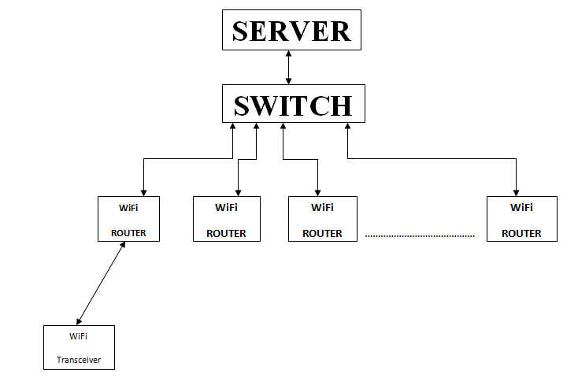

The wireless routers will be placed at different junctions in the building and all these routers will be connected to a common server through a switch. This database server will contain different audio files that have the details about the directions to be followed to reach different places in the building. The user will be provided with a wireless transceiver that has both a transmitter and a receiver. Whenever a transceiver is brought near a Wi-Fi router it can pair up with the nearby router’s wireless network in the building. Once it gets paired up with the router, the corresponding unique MAC address of the router is sent to the server. Thereby, the server can identify the connected router. When the router is identified the audio file with the required directions to be followed is sent back to the desired transceiver. The received audio file could be played using a headphone connected to the transceiver through the audio jack. When the user moves away from the Wi-Fi router, the transceiver will now get connected to the next Wi-Fi router and once again the required audio file will be provided by the server.

14.**INTRODUCTION:**

**ORIGIN OF THE PROPOSAL:**

Directions for the mobility of the visually challenged are usually provided with the help of another person or a guide. However, this makes it impossible for the visually challenged to move on their own without anyone’s help. Most places do not have any special amenities or facilities which help in the guiding of the visually challenged. This becomes a serious burden as their movements are restricted and they also require others help to move from one place to another. The overall goal of the project is to develop a new device which helps in guiding the visually challenged by providing continuous directions in the form of audio files.

**DEFINITION OF THE PROBLEM:**

CHALLENGES BEING FACED BY THE VISUALLY IMPAIRED PERSONS

1) WANT OF FREE MOBILITY

2) QUICK ACCESS TO THE DESTINATION

3) UNABLE TO AVAIL BENEFITS OF TECHNOLOGY.

4) UNABLE TO FEEL THE VISUAL ENJOYMENTS.

1) Want of Free mobility is the first and foremost challenge for the visually impaired**.**

Visually unable people facing the lack free mobility. This is causing hindrance even to meet out their day to day activities.

As well, visually unable people must learn every detail about the home environment. Large obstacles such as tables and chairs must remain in one location to prevent injury. If a blind person lives with others, each member of the household must diligently keep walkways clear and all items in designated locations.

The challenges of yesterday become the opportunities of today. The sensor attached sticks helps them in their moving.

2) QUICK ACCESS TO THE DESTINATION

Visually unable people cannot reach the destination in time, because, they had difficulties in finding out the required transportation and its stoppages. Even after reaching the Bus Stop or Railway station, he has to find out the bus number and whether it goes to his destination. Because of loss of time in finding out the bus number etc. he had to miss number of buses and to avail the help of others, since our transports are not having any audio system to announce the bus number and its routes. Because of this, visually unable persons reach their destinations belatedly and sometime, they might reach the wrong destinations thereby losing their opportunities.

As visually impaired people, they are taught to see life as a challenge; to face it and fight for their independence. This means to be persistent in what is important to them: equality and non-discrimination. Through this ongoing fight, many changes such as improved accessibility technology Braille and tools to help in daily living skills have aided them in showing the world that they can do the same things as anyone else.

With new opportunities however, comes the challenge that these opportunities are not foolproof. With our technology comes a dependence on electricity, which is greater than anyone else and is limited to where we can access these technologies. It remains impossible for them to simply browse the books in a bookstore; the scanners needed to accomplish this are too large to transport for such a task. They have to depend upon another person to do such things on their behalf.

They need to face oncoming problems with the right attitude. Attitude is what has allowed them to meet challenges in the past and have them transformed into opportunities.

Vision impairments can result from a variety of causes, including congenital conditions, injury, eye disease, and brain trauma, or as the result of other conditions such as diabetes and multiple sclerosis.

Bottom of Form

Test adaptation is another concern for blind students. Students will usually have a preference for taking tests. These preferences often involve either a reader or a taped Braille test. The student will either type the answers or dictate them to a proctor to record. Some may prefer to Braille their answers first and then read them for a scribe to record in longhand. Whatever method is proposed, the student and faculty member should agree early in the semester about how the student’s academic work would be evaluated.

UNABLE TO AVAIL THE BENEFITS OF TECHNOLOGY DEVELOPMENTS**.**

An ordinary person can use web pages and search and find out his requirements. But visually unable persons cannot use this technology and he has to depend upon others to view web page and search for his requirements. Likewise, visually challenged persons cannot use the present day developments in software world.

This certainly alleviates their career developments and stalls their goals in their life so as to compete with the ordinary person.

UNABLE TO FEEL THE VISUAL ENJOYMENTS

**Visually** challenged persons cannot enjoy the plenty of greeneries and sceneries presented by Thee to this world.

The aforementioned challenges being faced by Visually Impaired persons can be resolved by the

**“Wi-Fi Based Navigation System for the Visually Challenged “**.

16.**OBJECTIVE**

The objectives of this project are to;

1. Setup a server that has the different audio files with directions

2. Place Wi-Fi routers at different points and connect them to the server through a common switch.

3. Design a standalone system using a microcontroller with

3.5mm audio jack.

17. **REVIEW OF STATUS OF RESEARCH AND DEVOLOPMENT IN THE SUBJECT.**

There has already been a great deal of work done both in India and

abroad in the area of indoor navigation. Although the area of indoor navigation using Wi-Fi is less mature, there have been some recent breakthroughs incorporating the above mentioned practically .Here we list few ongoing researches in this field.

**INTERNATIONAL STATUS**

1. Application of WiFi-based Indoor Positioning System

in Handheld Directory System

LEE PIEH WEN, CHAN WEE NEE, KHOR MENG CHUN**,** TAN SHIANG-YEN, ROSNAH IDRUS

School of Computer Sciences

Universiti Sains Malaysia

MALAYSIA

chimera.nav.tech@gmail.com, tsy09_com036@student.usm, rosnah@cs.usm.my

ABSTRACT:

The purpose of this paper is to introduce a handheld indoor directory system which built on WiFi based positioning techniques. The whole system consists of three modules, namely mobile phone module, Kiosks module, and Website and Database module. The mobile phone module is the main frontend module which installed on users’ mobile devices, whereas the Kiosks and website are to provide supports and maintenances to the main module. User can download maps and application from the Kiosks or website. On the other hand, administrator uses the website to manage the database. The proposed system is aimed to provide a new way of providing indoor floor directory, which offers capabilities to retrieve customizable information, to navigate interactively, to enable location-awareness computing and most importantly the portability of the directory system. Additionally, the proposed system is designated to cater for the needs of visually challenged persons by incorporating screen reader and improved accessibility.

**Reference:**

http://www.wseas.us/e-library/conferences/2011/Paris/ECC/ECC-01.pdf

2. **“A Local Optimal User Position System for Indoor Wireless Devices”.**

THESIS

Author-Nicola Lenihan

Supervisor-Dr. Sean McGrath

University of Limerick

May 2004

ABSTRACT:

The Local Optimal User Position (LOUP) system proposed in this project determines

the location of the user in a Wireless Local Area Network (WLAN) and then

ascertains the closest position that will improve the service to the user. The location of

the user is identified using signal strength information. This information together with

the propagation model of the locality allows the system to determine if the user is

located in a low capacity area, for e.g. behind a cement pillar. In this situation, the

system directs the user to move to another location, which will have a better signal

strength value, in order to receive a better class of service.

**Reference:**

http://www3.ul.ie/mgbarry/Pubs/theses/Meng04_nicola_lenihan.pdf

19.**WORK PLAN**

**Methodology**

1. First setting up a server that stores different audio files.

2. Connecting the router to the server.

3. When a mobile is connected to the Wi-Fi, the MAC address of the router is sent to the server.

4. Using the MAC address as an identity the required audio file with the direction is sent back to the mobile.

5. Replacing the mobile phone with a microcontroller (with Wi-Fi module) that has a 3.5mm audio jack.

6. Finally, expanding the system with many Wi-Fi routers and Wi-Fi transceivers.

**Organisation of work elements**

The proposed project is organized as follows:

1. Creating a local server with audio files

2. Setting up the system with one Wi-Fi router and one Wi-Fi transceiver(mobile).

3. Finally, designing a smart standalone system using

microcontroller and additional hardwires.

20.**Suggested plan of action for utilization of research outcome**

**expected from the project.**

After successful completion of the project, the developed

smart standalone SLT system would help the visually challenged persons for indoor navigation without any hassles and reach the particular location safely by providing

vocal assistance. This system could be implemented in different Malls, Hospitals, Railway Stations, Schools, and Colleges etc.

Images of the Proposed Model.

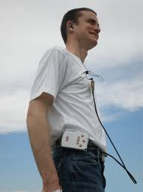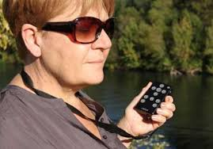

21.**FUTURE DIRECTIONS**

1. Extending the same system for outdoor navigation using GPS.

22. Detailed Bio-data of the Investigator(s)/Co-Investigator(s)

Bio-data of the PI and Co-PI is attached separately.

23. Any other relevant matter.